**EECE435L Lab5**

**Dana Kossaybati**

**Postman Requests**

**Note: For all the following** {{base_url}} = http://127.0.0.1:5000

1. **Create New User**

Snapshot: 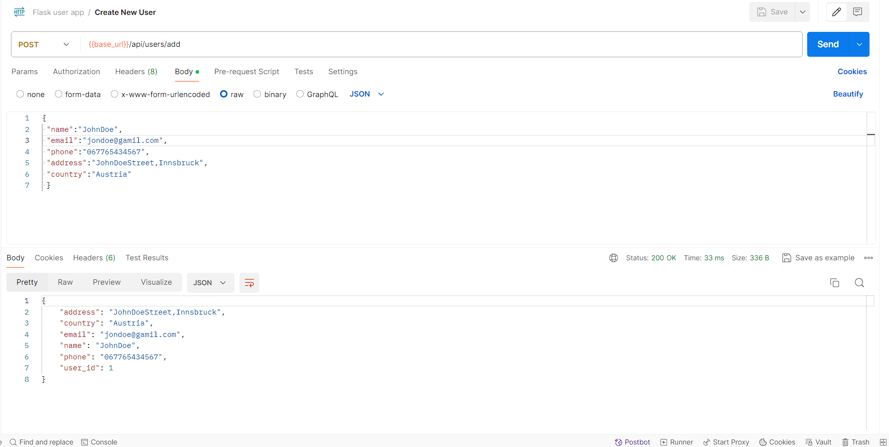

Request Type: POST

URL: {{base_url}}/api/users/add

Request Body:

{

    "address": "JohnDoeStreet,Innsbruck",

    "country": "Austria",

    "email": "jondoe@gamil.com",

    "name": "JohnDoe",

    "phone": "067765434567",

    "user_id": 1

}

Return Value:

{"address":"JohnDoeStreet,Innsbruck","country":"Austria","email":"jondoe@gamil.com","name":"JohnDoe","phone":"067765434567","user_id":1}

1. **Get All Users**

Snapshot: 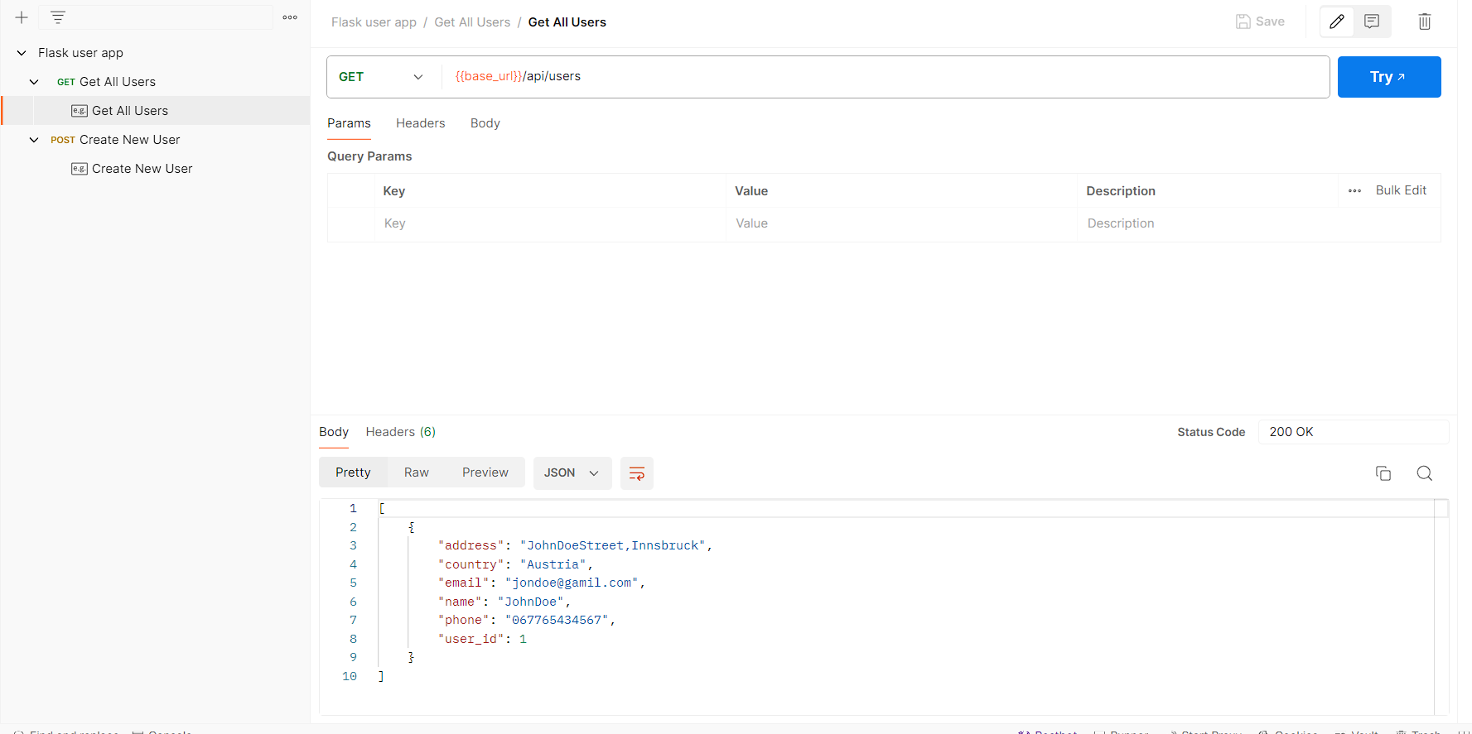

Request Type: GET

URL: {{base_url}}/api/users

Request Body: empty

Return Value:

[{"address":"JohnDoeStreet,Innsbruck","country":"Austria","email":"jondoe@gamil.com","name":"JohnDoe","phone":"067765434567","user_id":1}]

1. **Get User By ID**

Request Type: GET

URL: {{base_url}}/api/users/1

Request Body: empty

Return Value:

{"address":"JohnDoeStreet,Innsbruck","country":"Austria","email":"jondoe@gamil.com","name":"JohnDoe","phone":"067765434567","user_id":1}

1. **Update User**

Snapshot: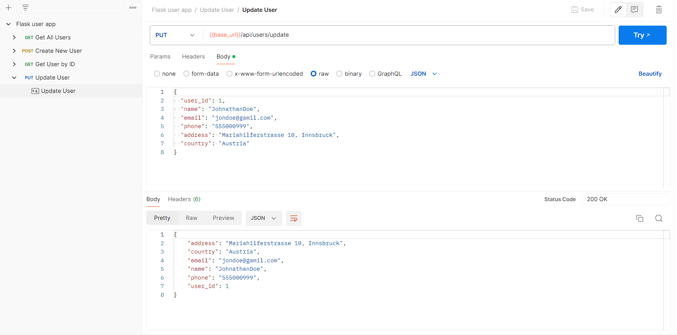

Request Type: PUT

URL: {{base_url}}/api/users/update

Request Body:

{

  "user_id": 1,

  "name": "JohnathanDoe",

  "email": "jondoe@gamil.com",

  "phone": "555000999",

  "address": "Mariahilferstrasse 10, Innsbruck",

  "country": "Austria"

}

Return Value:

{

    "address": "Mariahilferstrasse 10, Innsbruck",

    "country": "Austria",

    "email": "jondoe@gamil.com",

    "name": "JohnathanDoe",

    "phone": "555000999",

    "user_id": 1

}

1. **Delete User by ID**

Snapshot: 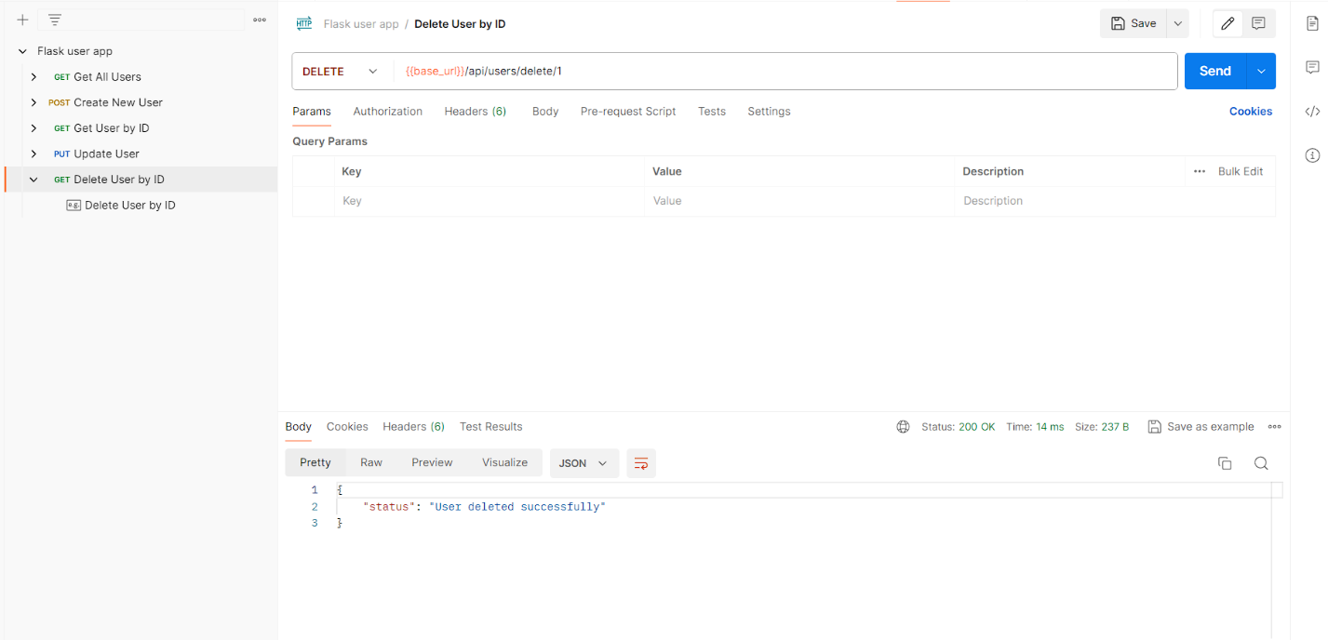

Request Type: DELETE

URL: {{base_url}}/api/users/delete/1

Request Body: empty

Return Value:

{

    "status": "User deleted successfully"

}